Replication of Priming Addition Facts With Semantic Relations by Bassok, Pedigo & Oskarsson (2008, Journal of Experimental Psychology: Learning, Memory, and Cognition)

Introduction

Bassok, Pedigo & Oskarsson (2008) provided evidence for the semantic alignment hypothesis, an account for how semantic alignments modulate automatic activation of arithmetically related facts. More precisely, the hypothesis states that categorical semantic relation is aligned with addition, and the functional semantic relation is aligned with division. The authors conducted two experiments, categorical semantic priming and functional semantic priming, to testify whether categorical aligned semantic primes automatically activate addition facts, at which they referred to this result pattern as the sum effect. The present study attempts to replicate Experiment 1 of the original study. The authors proposed that:
“…We predicted that the sum effect would be more pronounced in the semantically aligned than in the semantically misaligned priming condition. That is, we predicted that the difference between response latencies to sum and neutral targets (e.g., between 8 and 9, respectively, for cue digits 5 + 3) would be larger when the cue digits are primed with categorical primes (tulips–daisies) than when they are primed with unrelated primes (hens–radios) or with functionally related primes (birds– cages).”
Methods

Power Analysis
Given the absence of data about sum of squares for calculating the actual power in the original work, the effect size and power are unknown. Despite the missing data, sample size is estimated for the hypothesis test.

Planned Sample
Following the original study, two different groups of participants were sampled. As the original power and effect size were unknown due to missing of relevant data, the required sample size is estimated by using G*Power statistical calculator. Given it is 2 X 2 within subjects repeated measures analyses of variance, estimating the effect size in a range of small to moderate level (η_p^2 = .13), desired power .95, significance level .05, the calculated sample size is 84. The calculated sample size for the power .9 and .8 are 68 and 52 respectively. The data collection will begin from spring 2014 through to the end of the semester. Similar to the original study, the participants are native English speakers or at least as fluent as a native English speaker with normal or corrected vision.

Materials
We intend to mirror the experiment procedure and materials used in the original study (see Appendix A for the trial triplets). The written instructions and trial stimuli will display on a 15.4-in (39.1cm) monitor operated with an Intel Core 2 Duo computer and the trial responses will be recorded with the use of Visual Basics 2010 software (see Figure 1 for the experimental procedure). The stimuli are 80 word triplet pairs (aligned categorically related word and misaligned unrelated word triplets), and 48 digit triplet pairs in Experiment 1. The presentation time of stimuli and target will strictly follow the original study.

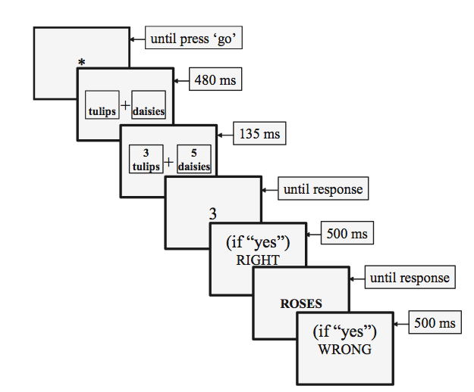
Figure 1. An illustration of the experimental procedure. Asterisk represents the prompt used at the outset of each trial.

Procedure
The procedure will follow the one used in the original study in Experiment 1. The details are below:

“Each participant received a unique randomized sequence of 160 trials that had a balanced 4 (word triplet) x 4 (digit triplet) x 2 (target order) factorial design, with five trials in each experimental cell. The four word-triplet conditions were AC prime/matching target, AC prime/nonmatching target, MU prime/matching target, and MU prime/nonmatching target. The four digit-triplet conditions were sum, neutral, cue control, and target control. The two target-order conditions were digit first and word first. The word triplets were selected at random without replacement until all 80 triplets were exhausted and then sampled again for a total of 160 trials. The digit triplets were selected at random without replacement until all 48 triplets were exhausted, and this sampling was repeated for a total of 160 trials. The constraints on the random draw of the word and digit combinations were such that there were no more than two consecutive identical trial types and no more than four identical consecutive correct responses (e.g., “no”).” (pp.347)
Analysis Plan
Following the procedure of the study of Bassok and colleagues (2008), the mean latencies of correct responses and mean error rates will be analyzed using within-subject repeated measures analyses of variance (ANOVAs).
(Post Data Collectin) Methods Addendum
Actual sample
Fifty participants were recruited. Data from one participant who failed to respond correctly on ninety-percent of trials were excluded. Thus, 49 participants remained in the final data analysis process.
Differences from pre-data collection plan
We were unable to recruit the target number of participants.
Results
Data preparation
According to the data analysis in the original study, the data used to test the hypothesis is restricted to the experimental trials in which the non-matching sum and neutral digit targets appeared first. Of these 40 experimental trials, half were preceded by aligned categorically related primes (AC), and half were preceded by misaligned unrelated primes (MU). The mean latencies of correct responses and mean error rates were analyzed in separate 2 (priming words: AC and MU) X 2 (digit target: sum and neutral) within-subject repeated measures ANOVAs.
Confirmatory analyses
Table 4 illustrated the mean latencies and mean errors rates. Consistent with the study findings of Bassok et al., 2008 and previous studies (LeFevre, Bisanz, & Mrkonjie, 1988), participants took significantly longer time to reject the sum (898ms) than the neutral digit targets (850ms), t(48)=3.44, p = .001. The null hypothesis was rejected by the significant Priming Words x Digit Target interaction, F(1, 48) = 4.22, MSE = 9,999, p = .045. For the AC condition, participants took 77ms longer to reject sum over neutral targets, t(48) = 3.37, p = .001. On the other hand, among the MU condition, participants did not show significant difference in rejecting sum versus neutral targets, t(48) = 1.14, p = .26. Therefore, the results can conclude showing the sum effects that it only occurred in the AC condition but not in the MU condition.
Furthermore, sum latencies were significantly longer in the AC condition than in the MU condition (70 ms), t(48) = 3.08, p = .003, whereas no such difference was found in the neutral latencies for both AC and MU conditions, t(48) = .66. p = .514. The results suggest that the sum effect is observed in the AC condition due to the activation of sum targets.
The mean errors and their standard errors presented in Table 4. The error rates across conditions were similar. The interaction between priming words and digit targets were also not significant, F(1,48) = .90, MSE = 151, p = 348.
Table 1.
Mean latencies and mean errors rates for sum and neutral targets in both priming conditions
 | AC primes |  | MU primes
Response | Sum | Neutral | Sum | Neutral
Latency
M | 933 | 856 | 864 | 845
SEM | 30 | 23 | 22 | 21
%Error
M | 22 | 22 | 23 | 18
SEM | 3 | 3 | 3 | 2

Reference
Bassok, M., Pedigo, S. F., & Oskarsson, A. T. (2008). Priming addition facts with semantic relations. Journal of Experimental Psychology: Learning, Memory, and Cognition, 34(2), 343-352.
Faul, F., Erdfelder, E., Buchner, A., & Lang, A.-G. (2009). Statistical power analyses using G*Power 3.1: Tests for correlation and regression analyses. Behavior Research Methods, 41, 1149-1160.
LeFevre, J., Bisanz, J., & Mrkonjie, L., (1988). Cognitive arithmetic: Evidence for obligatory activation of arithmetic facts. Memory & Cognition, 16, 45-53.

Appendix A



